THE ISSUE OF HUMAN TRAFFICKING

According to the UN, human trafficking is the recruitment, transportation, transfer, harbouring or receipt of people through force, fraud or deception, with the aim of exploiting them for profit. People of any background, gender or age can be victims of this crime, with it happening in all regions all around the globe. The traffickers often use violence or fraudulent employment agencies and fraudulent promises of employment to lure victims.

Human trafficking has many forms. These include exploitation in the sex, the online dissemination of abusive images, and as domestic workers or in forced marriages. Some may be forced to join armed forces or organized crime groups. Victims may be forced to work in factories, etc. without pay or with an inadequate salary, often living in fear and in inhumane conditions. Some can be coerced or forced to undergo organ harvesting, leaving them with life–threatening injuries or even resulting in deaths.

Human traffickers mostly target vulnerable members of society. Human traffickers often prey on the most vulnerable members of society, including children, the homeless, runaways, migrants, asylum seekers, refugees, and marginalized groups. These individuals are frequently targeted because of their vulnerability, desperation, or societal oppression. The reasons behind human trafficking are varied, with key factors including poverty, armed conflict, dysfunctional family environments, and inadequate parental care for children. Although trafficking seems to imply people moving across continents, most exploitation takes place close to home.

It’s necessary to understand why human trafficking occurs, in order to attempt to resolve the issue. Human trafficking is often fuelled by a high reward, low risk dynamic. This means that traffickers can expect to make a lot of profit with minimal fear of legal consequences or any other punishments. It’s the second most profitable illegal industry— second only to the drug trade. And while drugs are sold in one transaction, humans can be sold and exploited repeatedly. The costs are low, and the profits are extremely high. The International Labor Organization estimates that profits from human trafficking and forced labour are [$150 billion annually](http://www.ilo.org/global/topics/forced-labour/lang--en/index.htm).

It's also important to recognize the role of the internet and increasing use of social media within human trafficking. Many victims are approached by traffickers on social media. UNODC has identified two types of strategies, “hunting” involving a trafficker actively pursuing a victim, typically on social media and “fishing”, when perpetrators post job advertisements and wait for potential victims to respond. Technology can be misused by traffickers to launder or transfer illicit profits. However, social media also has its benefits with it also having a positive use in helping to combat trafficking, such as by aiding investigations, enhancing prosecutions, raising awareness, and providing services to victims.

According to the UNODC Global Report on Trafficking in Persons Report, the most common form of human trafficking is of a sexual nature – 79%. The second most common form of human trafficking is forced labour -18%. However, this may be misleading, as forced labour is simply reported less frequently than trafficking for sexual exploitation.

Although many countries have had anti-trafficking laws for years, convictions have only recently started to increase, following the rise in detected and reported victims. However, some areas still have low conviction rates and fewer victims found. This doesn’t mean traffickers aren't active in these areas, as victims from regions with low detection are often found in higher numbers elsewhere. And it’s also important to note that convictions rely on human trafficking being reported – which does not always happen.

So, what has the UN done so far? One of the primary bodies with regards to the issue of human trafficking is the UNODC – the United Nations Office on Drugs and Crimes, addressing the criminal aspects of human trafficking. It offers expertise and guidance to UN Member States, supporting them in ratifying and implementing the UN Protocol on Trafficking. Its crime prevention and criminal justice experts support the development of national laws and policies on human trafficking, train and mentor a wide range of officials, including police officers, border control guards, etc. With the guidance and mechanisms provided by UNODC, countries are better equipped to investigate and prosecute cases of human trafficking, dismantle the criminal networks behind this crime.

UNODC supports countries in implementing the Protocol. The United Nations Protocol against Trafficking in Persons, the leading international agreement on this issue, came into effect in 2003. The United Nations adopted the Protocol in November 2000 as part of the Convention against Transnational Organized Crime. It was the first legally binding document with an internationally recognized definition of human trafficking, crucial for identifying victims and detecting all forms of exploitation. Countries that ratify the Protocol are required to criminalize trafficking, create anti-trafficking laws, and protect victims, ensuring their rights are respected. Recent reports indicate that the number of Member States actively implementing the Protocol has more than doubled in recent years, increasing from 54 to 125 out of the 155 States reviewed. However, many countries still lack the essential legal frameworks or the political will to fully address the problem.

Despite these protocols and bodies as well as international conventions like the United Nations Protocol to Prevent, Suppress, and Punish Trafficking in Persons, enforcement remains inconsistent. Weak governance, corruption, and limited resources allow traffickers to act with impunity while victims often remain unnoticed or unsupported. Key challenges in combating human trafficking also include difficulty identifying victims in hidden sectors, weak or poorly enforced legal frameworks, corruption, and poor cross-border cooperation. Survivors also face barriers to justice and rehabilitation, such as fear, stigma, and inadequate support. This results in the issue of human trafficking persisting. 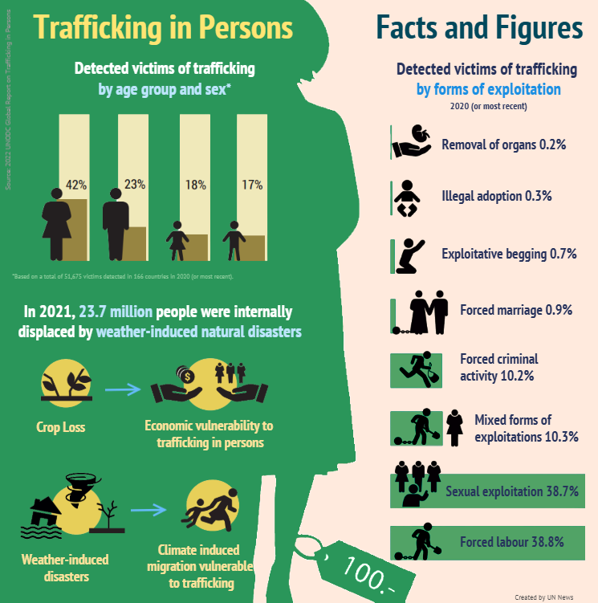

### **Points to Consider:**

* What actions can be taken to strengthen the enforcement of anti-trafficking laws and eliminate corruption that enables trafficking networks?
* How can international cooperation and action be improved to tackle worldwide trafficking?
* What measures can be put in place to ensure that survivors of human trafficking receive support?
* How can the misuse of technology by traffickers be minimised?
* What strategies can be developed to protect vulnerable groups, such as children, migrants, and refugees, who are most at risk of trafficking?

### **Useful Websites:**

* UNODC Global Human Trafficking Report - <https://www.unodc.org/unodc/en/press/releases/2024/December/unodc-global-human-trafficking-report_-detected-victims-up-25-per-cent-as-more-children-are-exploited-and-forced-labour-cases-spike.html>
* UN Protocol to Prevent, Suppress and Punish Trafficking in Persons - <https://www.unodc.org/unodc/en/press/releases/2024/December/unodc-global-human-trafficking-report_-detected-victims-up-25-per-cent-as-more-children-are-exploited-and-forced-labour-cases-spike.html>
* International Labour Organisation -   
  <https://www.ilo.org/topics-and-sectors/forced-labour-modern-slavery-and-trafficking-persons>
* Understanding Human Trafficking – UN -   
  <https://www.ilo.org/topics-and-sectors/forced-labour-modern-slavery-and-trafficking-persons>